**PROJECT REPORT**

|  |  |
| --- | --- |
| **Date** | **19 October 2022** |
| **Team ID** | **PNT2022TMID07573** |
| **Project Name** | **Nutrition Assistant Application** |

**TABLEOFCONTENTS**

**S.NO TITLE PG.NO**

1. **INTRODUCTION**
   1. Project Overview
   2. Purpose
2. **LITERATURESURVEY**
   1. Existing problem
   2. References
   3. Problem Statement Definition
3. **IDEATION & PROPOSED SOLUTION**
   1. Empathy Map Canvas
   2. Ideation& Brainstorming
   3. Proposed Solution
   4. Problem Solution fit
4. **REQUIREMENTANALYSIS**
   1. Functional requirement
   2. Non-Functional requirements
5. **PROJECTDESIGN**
   1. Data Flow Diagrams
   2. Solution & Technical Architecture
   3. User Stories
6. **PROJECTPLANNING&SCHEDULING**
   1. Sprint Planning & Estimation
   2. Sprint Delivery Schedule
   3. Reports from JIRA
7. **CODING & SOLUTIONING**
   1. SendGrid
   2. Database Schema
8. **TESTING**
   1. User Acceptance Testing
9. **RESULTS**
   1. Performance Metrics
10. **ADVANTAGES&DISADVANTAGES**
11. **CONCLUSION**
12. **FUTURESCOPE**
13. **APPENDIX**
    1. Source Code

GitHub Link

Project Demo Link

NUTRITION ASSISTANT APPLICATION

# INTRODUCTION

## Project Overview

The Nutrition Results Package is a ten-year program framework authorized in 1998. Under this authorization, The Food and Nutrition Technical Assistance (FANTA) project was awarded competitively in September 1998 to the Academy for Educational Development (AED) as the prime contractor, with Cornell University and Tufts University as subcontractors. The FANTA proposal included a memorandum of understanding with Food Aid Management (FAM)1 , a consortium of Private Voluntary Organizations (PVOs), referred to as Cooperating Sponsors (CS), implementing Title II food aid development and emergency programs.2 The overall purpose of FANTA is "improved food and nutrition policy, strategy, and program development". Three Intermediate Results (IRs) were identified to achieve this purpose: IR.1. USAID's and Cooperating Sponsors' nutrition and food security- related program development, analysis, monitoring, and evaluation improved, IR.2. USAID, host country governments, and Cooperating Sponsors establish improved, integrated nutrition and food security- related strategies and policies, and IR.3. Best practices and acceptable standards in nutrition and food security-related policy and programming adopted by USAID, Cooperating Sponsors, and other key stakeholders. The Cooperative Agreement states that the central activity of FANTA is to provide technical assistance to USAID, Title II PVOs, and host governments in planning and implementing cost- effective programs that can bring about measurable

changes in the nutritional status of target populations. FANTA is unique in that it is charged with taking a broad approach to food security by assisting Missions and partners to examine how non- nutrition programs can be used to improve nutrition and to help ensure that investments in nutrition are focused on the best possible mix of interventions to achieve food security. The FANTA mandate is threefold: · To provide technical assistance to programs, · To lead or contribute to policy discussions, and · To identify and document promising practices and sponsor their dissemination. 1 Food Aid Management is a consortium of a number of private voluntary organizations that collaborate on technical and administrative issues related to food aid programming 2 The terms private voluntary organization (PVO) and cooperating sponsor are used interchangeably in this report. FOOD AND NUTRITION TECHNICAL ASSISTANCE PROJECT ASSESSMENT 2 Technical assistance includes face-to-face meetings with program officials and staff to identify and solve problems; written materials such as technical updates, state-of-the-art guides on programming, and summaries of lessons learned; and formal reviews of Title II program proposals, implementation plans, program evaluations, and training activities. The primary partners in FANTA include the following: · Fifteen PVOs that design and implement more than 80 Title II development (nonemergency) programs in 27 countries. PVOs carry out interventions across many sectors, particularly agriculture; natural resources; microfinance; education; water and sanitation; health; nutrition; and information, education, communications, and behavior change activities. · Global Bureau/Office of Population, Health and

Nutrition (G/PHN), particularly for maternal health, child health, and HIV/AIDS teams and projects. · Bureau of Humanitarian Response (BHR) Food for Peace (FFP) Program. · USAID Missions and PVOs in 4–6 priority countries. · REDSO/ESA and Africa Bureau. · Tufts University, Cornell University, International Food Policy and Research Institute (IFPRI), World Health Organization (WHO), and Freedom from Hunger (FFH).

**Purpose**

The overall purpose of the IR.1 is to improve food security and nutrition programming by supporting USAID/BHR/FFP and its Cooperating Sponsors. The aim of the intermediate result is to strengthen the capacity of stakeholders who analyze food and nutrition security problems, and who design projects and report their progress. Food aid programs are important because they provide nutrition directly to people, and because food aid programs are designed to complement other health and nutrition activities. Over the last few years the policy and strategy have shifted away from short-term programs that focused on meeting immediate needs through nutrition supplements to a longer-term, sustainable food security plan. As part of this shift, there has been an emphasis on using Title II development (nonemergency) resources to focus on improving agricultural productivity and nutrition for mothers and children. Humanitarian assistance is the focus of the Title II emergency program. The expected results have been defined in FANTA’s Results Framework and Performance Indicators (Figure 1): · Percentage of Cooperating Sponsor food aid proposals (FFP/DP) assessed to satisfy Agency

review criteria in problem assessment, performance indicators, intervention design, and monitoring and evaluation plan. · Percentage of development food aid Cooperating Sponsor programs (FFP/DP) able to meet USAID’s reporting requirements, including annual submissions, baselines, and evaluations. · Percentage of FFP/EP reporting positive change or maintenance of nutritional status. · Percentage of Cooperating Sponsors able to meet FFP/EP reporting requirements. Much of the discussion in the following section is focused on the Title II development program.

1. **URE SURVELITERATY**

**Existing problem**

Healthy nutrition contributes to preventing non-communicable and diet-related

diseases. Recommender systems, as an integral part of mHealth technologies,

address this task by supporting users with healthy food recommendations.

However, knowledge about the effects of the long-term provision of health-aware

recommendations in real-life situations is limited. This study investigates the

impact of a mobile, personalized recommender system named Nutrilize. Our

system offers automated personalized visual feedback and recommendations

based on individual dietary behaviour, phenotype, and preferences. By using

quantitative and qualitative measures of 34 participants during a study of 2–3

months, we provide a deeper understanding of how our nutrition application

affects the users’ physique, nutrition behaviour, system interactions and system

perception. Our results show that Nutrilize positively affects nutritional behaviour

(conditional R2=.342R2=.342) measured by the optimal intake of each nutrient.

The analysis of different application features shows that reflective visual feedback

has a more substantial impact on healthy behaviour than the recommender

(conditional R2=.354R2=.354). We further identify system limitations influencing

this result, such as a lack of diversity, mistrust in healthiness and personalization,

real-life contexts, and personal user characteristics with a qualitative analysis of

semi-structured in-depth interviews. Finally, we discuss general knowledge

acquired on the design of personalized mobile nutrition recommendations by

identifying important factors, such as the users’ acceptance of the recommender’s

taste, health, and personalization.

## References

Development of a cloud-based solution for effective Nutrition Intervention in the Management of Lifestyle Diseases, A web-based tool is being planned for therapeutic nutrition prescriptions in clinical settings. The cloud-based system would have the ability to calculate the nutritional requirements and to guide first line nutritional management to patients and clients automatically. Also, it serves as an electronic medical and dietetic record, and personalized nutrition consultation approach can be client can converse to his/ her personal dietitian at their own convenient setting. A Diet control fitness assistant application using Deep Learning based image classification. With more and more attentions paid on health, people begin to care about healthy diet options created by experts on nutrition. However, it will take a long time to observe the effects by taking healthy diet. This causes great difficulty for users to follow the healthy diet strictly. Most existing applications are not user-friendly in inputting information to the application. Enhancing cloud and Big Data Systems for healthy food and information systems Practice, Cloud Computing is a kind of virtualization technology based on internet. In cloud computing, central remote server plays an important role for healthy data management and applications. It offers handsome efficiency in the field of Computing as well as Information Technology for providing centralized storage, money, processing, and bandwidth, Digital Nutrition Consultation among Hand-Held Device Users During COVID-19 Pandemic. Nutrition and clinical dietetic services provide evidence-based support which has become essential for maintaining healthy lifestyle and avoiding malnutrition among population. National health with digital technology integration is gaining importance in the current COVID-19 pandemic scenario. Digital health technologies offer valuable means for community to create and share information about healthcare, Effectiveness of Game-based Learning of a National Health e-Learning Network for nutrition education in elementary school, this research intended to study the effects of utilizing games in health e- learning network on teaching third graders in elementary schools about

nutrition. The studied groups of this research were 2 classes of 33 third graders; the two classes were separated into experimental and control group. The experiment was implemented in a four-week duration. The experimental group learned the knowledge of nutrition based on game playing on a national health e- learning network, whereas the control group was lectured

## Problem Statement Definition

Due to the ignorance of healthy food habits, obesity rates are increasing at an alarming speed, and this is reflective of the risks to people’s health. People need to control their daily calorie intake by eating healthier foods, which is the most basic method to avoid obesity. However, although food packaging comes with nutrition (and calorie) labels, it’s still not very convenient for people to refer to App-based nutrient dashboard systems which can analyze real-time images of a meal and analyze it for nutritional content which can be very handy and improves the dietary habits, and therefore, helps in maintaining a healthy lifestyle. The main objective of this project is to building a web App that automatically estimates food attributes such as ingredients and nutritional value by classifying the input image of food.

# IDEATION & PROPOSED SOLUTION

## Empathy Map Canvas

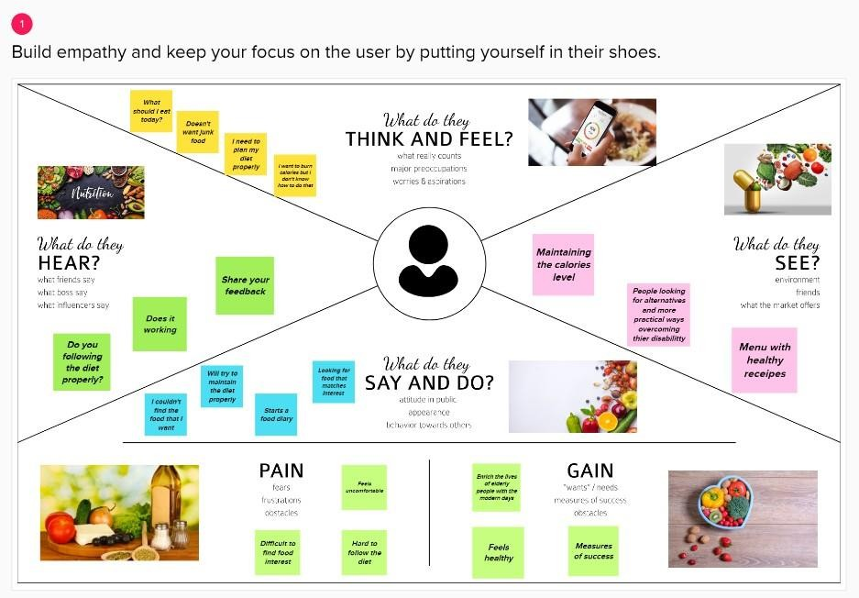

**Ideation & Brainstorming**

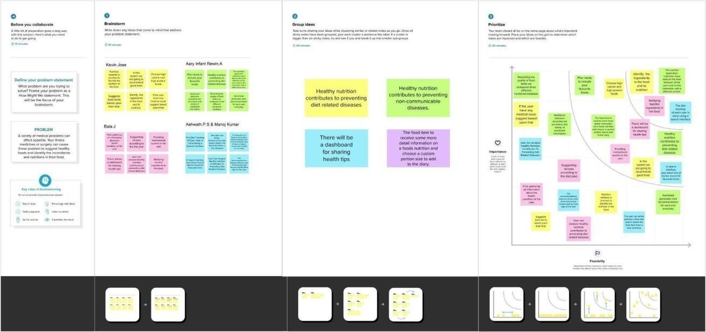

**Proposed Solution**

Now a days peoples are not eating healthy foods with respect to their health condition. If it happens continuously means, it will lead to obesity and any other health problems. To avoid that the system will detect and recognize the food and evaluating the nutrient values present in the food. To store the food and details of the nutrients present in it. Then scan the real time food and retrieve the corresponding food’s nutrient values. Clustering the peoples based on their BMI value. The application which gives awareness among the people about the obesity and various health problems In market, this application gives a benefit across the people by health wise and economical wise The application which creates an impact among the healthy lifestyle

## Problem Solution fit

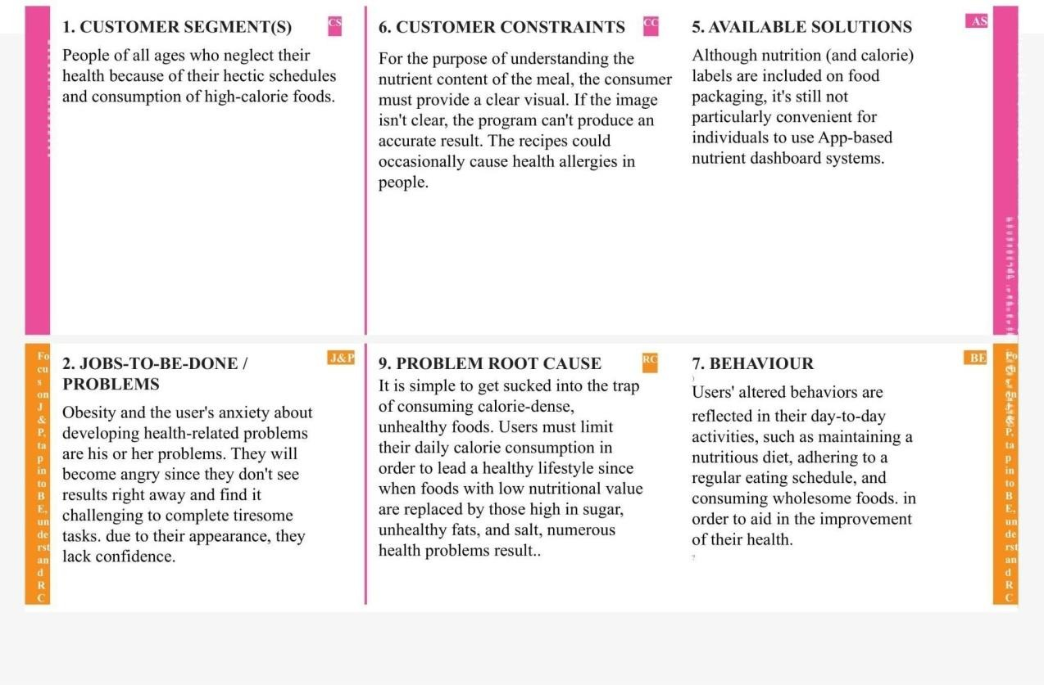

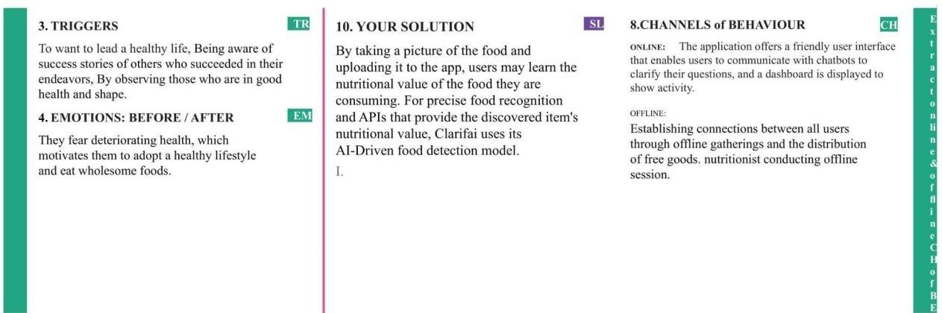

1. **REQUIREMENT ANALYSIS**

Functional requirement

Following are the functional requirements of the proposed solution.

|  |  |  |
| --- | --- | --- |
| **FR No.** | **Functional Requirement (Epic)** | **Sub Requirement (Story / Sub-Task)** |
| FR-1 | User Registration | Registration through E-mail and Phone number |
| FR-2 | User Confirmation | Confirmation via Email  Confirmation via OTP |
| FR-3 | User Profile Completion | Get personal details like height, weight, etc. |
| FR-4 | Gather meal image | Upload photo  Take live photo of the meal |
| FR-5 | Display calorie information | Integrate Califia API to get name of the food Integrate  Nutrition API (rapid API) to collect calorie information |

Non-Functional requirements

Following are the non-functional requirements of the proposed solution.

|  |  |  |
| --- | --- | --- |
| **FR No.** | **Non-Functional Requirement** | **Description** |
| NFR-1 | **Usability** | Provide user friendly UI  Simple and intuitive design |
| NFR-2 | **Security** | Comprehensive authorization and authentication  scheme for each system actor |
| NFR-3 | **Reliability** | The system must perform without failure in 95 percent of use cases |
| NFR-4 | **Performance** | The landing page supporting several users must  provide 5 seconds or less response time |
| NFR-5 | **Availability** | Uninterrupted services must be available all time  except the time of server updating. |
| NFR-6 | **Scalability** | Provide horizontal or vertical scaling for higher workloads |

# PROJECT DESIGN

## Data Flow Diagrams

A Data Flow Diagram (DFD) is a traditional visual representation of the information flows within a system. A neat and clear DFD can depict the right amount of the system requirement graphically. It shows how data enters and leaves the system, what changes the information, and where data is stored.

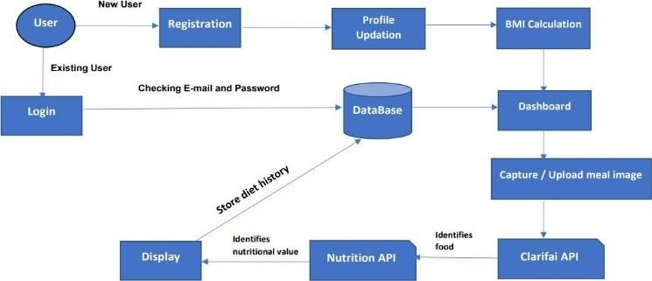

## Solution & Technical Architecture

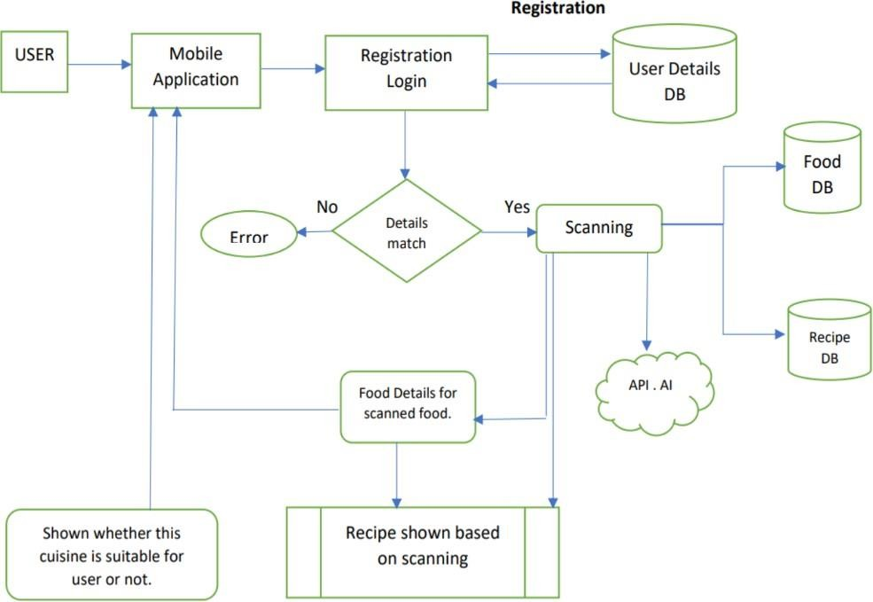

**User Stories**

|  |  |  |  |  |  |  |
| --- | --- | --- | --- | --- | --- | --- |
| **User Type** | **Functional Requirement (Epic)** | **User**  **Story Number** | **User Story / Task** | **Acceptance criteria** | **Priorit y** | **Release** |
| Customer | Registration | USN-1 | As a user, I can register for the application by entering my Name, Age, Gender, E-mail, password,  and confirming my password. | I can access my account / dashboard. | High | Sprint-1 |
|  |  | USN-2 | As a user, I will receive confirmation email once I have registered for the application. | I can receive confirmation email & click  confirm. | High | Sprint-1 |
|  | Profile updating | USN-3 | As a user, I have to enter my height, weight and daily activity details. | I can update this information on Dashboard. | High | Sprint-1 |
|  | Login | USN-4 | As a user, I can login to the application by entering E-mail  and password. | I can access my account/  dashboard. | High | Sprint-1 |
|  | Dashboard | USN-5 | As a user, I can upload or capture live image of the meal | I can get the  nutritional value of that particular meal. | High | Sprint-2 |
|  |  | USN-6 | As a user, I can track my daily calorie intake. | I can access my account/ Dashboard. | Mediu m | Sprint-2 |
| Administrator | Maintain the Application | USN-7 | Maintaining details for users. | I can access database. | High | Sprint-3 |

1. **PROJECT PLANNING & SCHEDULING**

**Sprint Planning & Estimation:**

Setting Up Application Environment To create lots of environment. Create or Enrolment to the IBM cloud, Docker CLI installation, create an account in SendGrid and Nutrition API, etc., Implementing Web Application We create a UI to interact with application. Create database system DB2 and connect it with python and integrate with Nutrition API.Integrating SendGrid Service SendGrid integration with python code for include some Rest API services for to give a Nutrition and calorie value. Deployment of App in IBM Cloud In the deploy process, the deployment in Kubernetes cluster is the major task before that we need to containerize the app and upload image to IBM container Registry.

## Sprint Delivery Schedule:

|  |  |  |  |  |  |  |
| --- | --- | --- | --- | --- | --- | --- |
| **Sprint** | **Total Story**  **Points** | **Duration** | **Sprint Start Date** | **Sprint End Date (Planned)** | **Story Points Completed (as on Planned End Date)** | **Sprint Release Date (Actual)** |
| Sprint-1 | 20 | 6 Days | 24 Oct 2022 | 29 Oct 2022 | 20 | 29 Oct 2022 |
| Sprint-2 | 20 | 6 Days | 31 Oct 2022 | 05 Nov 2022 | 20 | 05 Nov 2022 |
| Sprint-3 | 20 | 6 Days | 07 Nov 2022 | 12 Nov 2022 | 20 | 16 Nov 2022 |
| Sprint-4 | 20 | 6 Days | 14 Nov 2022 | 19 Nov 2022 | 20 | 19 Nov 2022 |

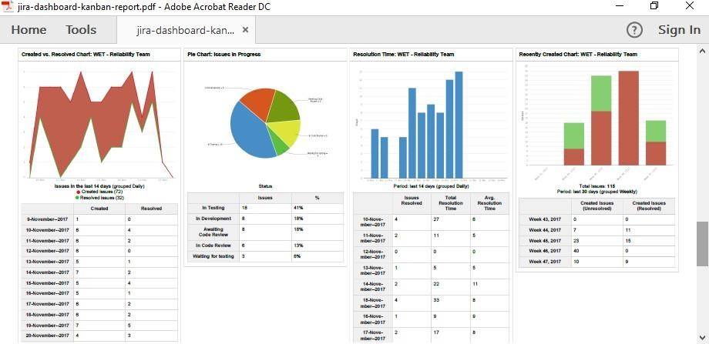**Reports from JIRA:**

1. **CODING & SOLUTIONING**

**Feature 1:**

Instant Information: The phrase “just Google it” holds special relevance in our day to day lives. It is the mobile apps that allow you to search the content instantly anywhere, anytime. Apps are reported to be [1.5 times](https://medium.com/%40KNOWARTH/9-advantages-of-mobile-apps-over-responsive-ecommerce-websites-6aed1e6db0d8) faster as compared to websites and perform actions at a faster pace too. Human minds are inquisitive and smartphone applications serve as an instant relief for this inquisitiveness. Instant Connection & Communication: Mobile phones and the internet have made this world a small place. There are ample of apps that allow a person to instantly connect and communicate another person living miles away. Apps have played a vital role in helping us in maintaining a healthy work-life balance. Better Productivity: According to a [report](https://www.digitalturbine.com/blog/the-rise-of-mobile-how-mobile-apps-have-changed-our-lives/) released by Accenture, business employees acknowledge the fact that smartphone apps play a critical role in their smooth business operations. Earlier people can access professional emails and messages from office computers only. Now with the help of various apps and an internet connection they can check their emails and messages from anywhere in the world. Even if you’re holidaying with your family, you can stay connected with your business updates with just a simple tap. This will contribute to your productivity as well.

## Feature 2:

Personal Accounts and Registration: Personalization is the key feature of every health and nutrition app. If a user can feed his personal health details and can get suitable advice, what more they can ask for? Make sure you have a feature to gather and analyze every user’s data pertaining to his or her weight, age, eating habits, allergies, level of physical activity, weight goals, and so on. Food Logging and Dashboard: A top-notch health and nutrition app should have a duly designed dashboard and a food logging feature. You need to prepare a database consisting of all diet information in it like calories, food intake, energy proportion, hydration meter and so on. It is almost impossible to develop this database on your own so why not use a ready-made API for this purpose? You can get this application programming interface for free. All you need to do is fill a form on the respective company’s website and wait for the approval. Simple, isn’t it? Push Notifications: Push notifications hold a special relevance in smartphone apps. If you too wish to go for a healthcare mobile app development, make sure you don’t lag behind in this! Install this feature to remind your users for their upcoming meal and motivate them to achieve their health and nutrition goals. Control the frequency of notifications as it can easily annoy the users.

## Database Schema:

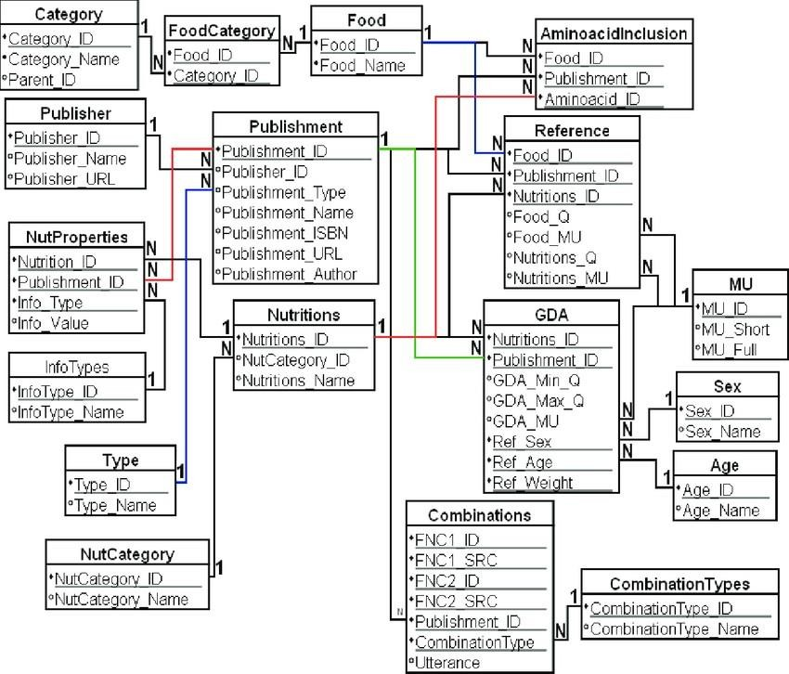

1. **TESTING**

**Test Cases:**

With a concerted effort, I conducted research on general well-being to have a rudimentary grasp on health management, as well as the existing nutrient tracking apps in order to get an understanding of what is already existing in the market, the characteristics, specialties, and usability. There are a considerable number of nutrition tracking apps existing in the market. They aim to track daily calories/macros intake by logging meals to achieve users’ preset goals. To log meals, users can input the food in the app, or scan the barcode of a package. Most apps allow users to connect with associated activities apps to track exercise progress. With a premium upgrade, users can get access to tailor-made recipes according to health goals or specified diets. In order to build a realistic initial target group, I wanted to conduct some usability tests with 5 users that regularly engage in physical activity and food tracking, including both first-time and regular users of meal planning and fitness apps. I asked these individuals to perform tasks related to general usage of the MyFitnessPal, Life sum, and Nutrition Coach apps (such as food logging, searching, and checking their caloric breakdown.)

|  |  |  |
| --- | --- | --- |
| Test Description | Expected | Result |
| Connect to Desktop site | Login page should be displayed | Passed |
| Login with wrong password | Should fail to login | passed |
| Login with correct password | Should show Dashboard | passed |
| Search for diet plans | Should show plans | passed |
| Enroll into a plan | Should be enrolled | passed |
| Again enroll | Should not enroll | passed |

## User Acceptance Testing:

Must-have features of a diet and nutrition app I wanted to address the user pain points by including (and improving) the core features of the application. Personal profiles After downloading the app, a user needs to register and create an account. At this stage, users should fill in personal information like name, gender, age, height, weight, food preferences, allergies, and level of physical activity. Food logging and dashboard Allowing users to analyze their eating habits. They should be able to log food and water intake and see their progress on a dashboard that can track calories, fat, protein, and carbs. Push notifications Push notifications are an effective tool for increasing user engagement and retention. To motivate users to keep moving toward their goals, it’s pertinent to deliver information on their progress toward the current goal and remind them to log what they eat. Calorie counter Enabling the application to calculate calories users have burned and eaten based on the data they’ve logged. Barcode scanner Let users count calories and see accurate nutrition information via a built-in barcode scanner. Recipe book Users will appreciate the opportunity to find healthy recipes in the app. Including pictures, videos, and even voice instructions in your recipes would be a valuable feature. Also, allowing users to rate recipes and sort them by keywords, ingredients, categories, and calories. Diet plans Help users maintain a healthy diet by offering diet plans. Usually, a diet plan includes meal suggestions, nutritional tips, recipes, and recommended total calorie intake per week or day. Gamification Including game elements to increase user engagement and retention. Using ranks, badges, and points to reward users for achievements such as losing weight or completing goals. Integration with wearables There are different trackers and wearables to integrate with. For example, Apple Watch, Android Wear, Jawbone, Fitbit, and Samsung Gear to synchronize data on physical activity and health metrics. Nice-to-have features of a diet and nutrition app Since nutrition apps can have different purposes, their functionality can differ accordingly. Below are features that I considered including later on or that could be useful for some nutrition apps. Blog A lot of users want a diet and nutrition application to not only

count calories but also share some diet tips to help them improve eating habits. This is where blogs come in handy. There, the latest food and nutrition research, news, and health tips could be shared. Shopping list Letting users import ingredients from a diet plan or a recipe to a shopping list or add groceries manually. Experts Users will definitely appreciate being able to get in touch with diet coaches for expert advice. This could be a paid feature. User Personas From the interview and observation sessions, I collected and synthesized some information that can be used in the upcoming design process. I could clearly define 2 user profiles from the research data. A casual dieter who does not follow a health plan regularly: Enise is a full-time student who needs reminders, suggestions, and coaching to cook more often with fresh ingredients because they want to stay on top of their health and make it a part of their routine.

|  |  |  |
| --- | --- | --- |
| Should alert the user for their daily plan | An alarm must be set off | passed |
| Should create log of their diet plan | A text file should be created with previous diet plans | passed |
| Should suggest new plans | Notification rolling for important messages | passed |
| During the completion of successful diet plan a new thanking window should open | A new popup should display saying u have completed your diet plans | passed |
| Nutrition amount display | Total nutrients consumed must be displayed | passed |
| Incomplete display | An alert and a popup display should be displayed | passed |
| Logout display | Should successfully logoff the credentials | passed |

# RESULTS

## Performance Metrics:

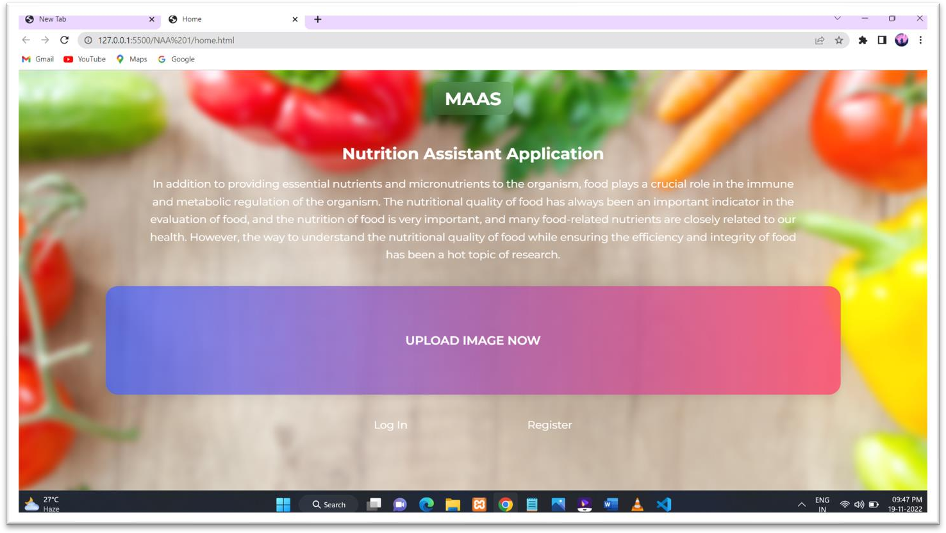

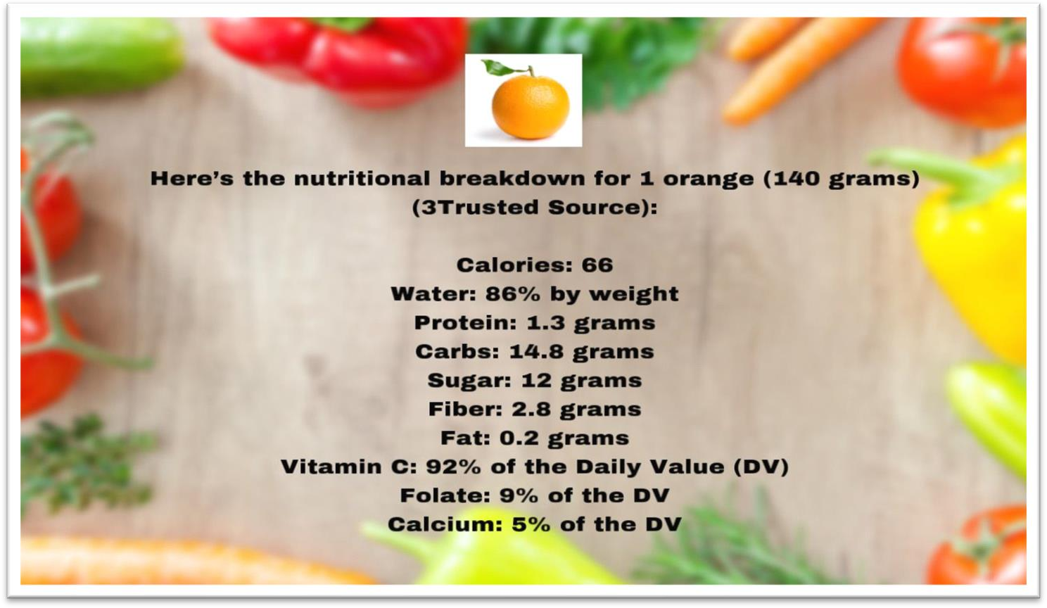

1. **ADVANTAGES & DISADVANTAGES**

**Advantages: -**

1. This device is user friendly.
2. Its only required the image of the food.
3. To know the different type of nutrients, present in food.
4. And also know that how much composition of the nutrients are present.
5. Output of the screen is easy understandable.

## Disadvantages: -

1. This device is not able to predict the multiple images as input.
2. The internet is only necessary for opening the web application. (After converting the mobile app internet is not necessary for opening.)

# CONCLUSION

During this assignment we were able to take a closer look at our daily eating habits. From here we can now improve our application so that we can help clients to eat and grow healthier as a person and athlete. I can truly say that I learnt a lot from this assignment. I was able to point out changes I needed to make and how to move forward and make it work in my life. I am now more educated on the powers of food and how they control our body. I hope that people will use our application to lead a healthy life. When choosing the right foods for yourself you should be focused on what is the healthiest choice. Eating healthy and feeling good go hand in hand, eating better will automatically give you a better functioning body. Eating healthy means eating a variety of foods that meet your daily requirements. We would recommend our application to anyone who is interested in eating healthy. Not only is it easy to use, but it is a great way to evaluate what you are eating and understand the vitamins and minerals that you need.

# FUTURE SCOPE

The device will also assist you determine the quantity and degree of flavour of the food. Future goals include increasing the accuracy of our machine learning model and expanding the types of food categories so that we can better meet user needs. We are also increasing dataset of categories of images and nutrition to better efficiency to get output. Our research essentially identifies simply the nutrients, but our team members raise the bar for our project so that we also understand the ingredients and the amount of nutrients in a particular cuisine.

# APPENDIX

## Source Code

Home.html:

<!DOCTYPE html>

<html lang="en">

<head>

<meta charset="UTF-8" />

<meta http-equiv="X-UA-Compatible" content="IE=edge" />

<meta name="viewport" content="width=device-width, initial-scale=1.0" />

<title>Home</title>

<link rel="preconnect" href="https://fonts.googleapis.com">

<link rel="preconnect" href="https://fonts.gstatic.com" crossorigin>

<link href=["https://fonts.googleapis.com/](https://fonts.googleapis.com/css2?family=Montserrat%3Aital%2Cwght%40)c[ss2?family=Montserrat:ital,wght@](https://fonts.googleapis.com/css2?family=Montserrat%3Aital%2Cwght%40) 0,100;0,200;0,300;0,400;0,500;0,600;0,700;0,800;1,400;1,600&display=swap"

rel="stylesheet">

<link rel="stylesheet" href="stylesheet.css"

/>

</head>

<body>

<div class="main">

<div id="continer">

<a href="/home.html"><span id="logao"><p id="logo-i">BMSZ</p></span></a>

</div>

<div id="continer-text">

<h2>Nutrition Assistant Application</h2>

<p>In addition to providing essential nutrients and micronutrients to the organism, food plays a crucial role in the immune and metabolic regulation of the

organism. The nutritional quality of food has always been an important indicator in the evaluation of food, and the nutrition of food is very important, and many food-related nutrients are closely related to our health. However,

the way to understand the nutritional quality of food while ensuring the efficiency and integrity of food has been a hot topic of research.</p>

</div>

<div id="continer">

<div id="continer-img">

<span id="text-btn"><a href="/upload_image.html">UPLOAD IMAGE NOW</a>

</span>

</div>

</div>

<div id="continer">

<div id="cointiner-inline">

<a href="/login.html" id="list">Log In</a>

<a href="/signup.html" id="list">Register</a>

</div>

</div>

</div>

</body>

</html>

Login.html:

<!DOCTYPE html>

<html lang="en">

<head>

<meta charset="UTF-8" />

<meta http-equiv="X-UA-Compatible" content="IE=edge" />

<meta name="viewport" content="width=device-width, initial-scale=1.0" />

<title>Log In</title>

<link rel="preconnect" href="https://fonts.googleapis.com">

<link rel="preconnect" href="https://fonts.gstatic.com" crossorigin>

<link href=["https://fonts.googleapis.com/](https://fonts.googleapis.com/css2?family=Montserrat%3Aital%2Cwght%40)c[ss2?family=Montserrat:ital,wght@](https://fonts.googleapis.com/css2?family=Montserrat%3Aital%2Cwght%40) 0,100;0,200;0,300;0,400;0,500;0,600;0,700;0,800;1,400;1,600&display=swap"

rel="stylesheet">

<link rel="stylesheet" href="stylesheet.css"

/>

</head>

<body>

<div class="main">

<div id="continer">

<a href="/home.html"><span id="logao"><p id="logo-i">BMSZ</p></span>

</a>

</div>

<div id="continer">

<div id="form">

<h2 id="heading">LOGIN</h2>

<form method="POST" action="">

<div> <input type="text" placeholder="Username" name="user" required />

</div>

<div> <input type="password" placeholder="Password" name="password" required/></div>

<input type="submit" value="Log In" />

</form>

<span id="text"><a href="/signup.html">Register Now</a></span>

<span id="text" class="s-text"><a href="/change_password.html">Change Password</a></span>

</div>

</div>

</div>

</body>

</html>

Signup.html:

<!DOCTYPE html>

<html lang="en">

<head>

<meta charset="UTF-8" />

<meta http-equiv="X-UA-Compatible" content="IE=edge" />

<meta name="viewport" content="width=device-width, initial-scale=1.0" />

<title>Sign Up</title>

<link rel="preconnect" href="https://fonts.googleapis.com">

<link rel="preconnect" href="https://fonts.gstatic.com" crossorigin>

<link href="https://fonts.googleapis.com/css2?family=Montserrat:ital,wght @0,100;0,200;0,300;0,400;0,500;0,600;0,700;0,800;1,400;1,600&

display=swap" rel="stylesheet">

<link rel="stylesheet" href="stylesheet.css"

/>

</head>

<body>

<div class="main">

<div id="continer">

<a href="/home.html"><span id="logao"><p id="logo-i">BMSZ</p></span></a>

</div>

<div id="continer">

<div id="form">

<h2 id="heading">REGISTER</h2>

<form method="POST" action="">

<div> <input type="text" placeholder="Username" name="user" required/>

</div>

<div> <input type="text" placeholder="Email" name="email" required/>

</div>

<div> <input type="password" placeholder="Password" name="password" required/>

</div>

<input type="submit" value="Sign Up" />

</form>

<span id="text">Already Have an account &nbsp;<a href="/login.html">

<span id="text-a"> Log In</span></a></span>

</div>

</div>

</div>

</body>

</html>

Stylesheet.css:

body{ margin: 0%;

font-family: 'Montserrat', sans-serif;

}

.main {

height: 100vh;

background: linear-gradient(45deg, #FC466B, #3F5EFB);

}

#continer{ display: flex;

justify-content: center;

}

#logo-i{

background-color: #ffffff08; backdrop-filter: blur(20px); color: #ffffff;

font-weight: 700; font-size: 30px; margin: 0 auto; padding: 10px 20px; margin-top: 20px; border-radius: 10px;

box-shadow: rgba(0, 0, 0, 0.2) 0px 18px 50px -10px;

}

#form{

background-color: #ffffff08; backdrop-filter: blur(20px); padding: 50px;

margin-top: 30px;

border-radius: 10px;

box-shadow: rgba(0, 0, 0, 0.2) 0px 18px 50px -10px;

}

#form-search{

background-color: #ffffff08; backdrop-filter: blur(20px); padding: 30px 50px 15px 50px; margin-top: 30px;

border-radius: 10px;

box-shadow: rgba(0, 0, 0, 0.2) 0px 18px 50px -10px;

}

GitHub link : https://github.com/Shreetha12/IBM-Project-53107-1661313929

Video link : [https://drive.google.com/file/d/1kQFQ1xc60iCLkWY1_KNDE-](https://drive.google.com/file/d/1kQFQ1xc60iCLkWY1_KNDE-2tbl00Rg22/view?usp=drivesdk) [2tbl00Rg22/view?usp=drivesdk](https://drive.google.com/file/d/1kQFQ1xc60iCLkWY1_KNDE-2tbl00Rg22/view?usp=drivesdk)